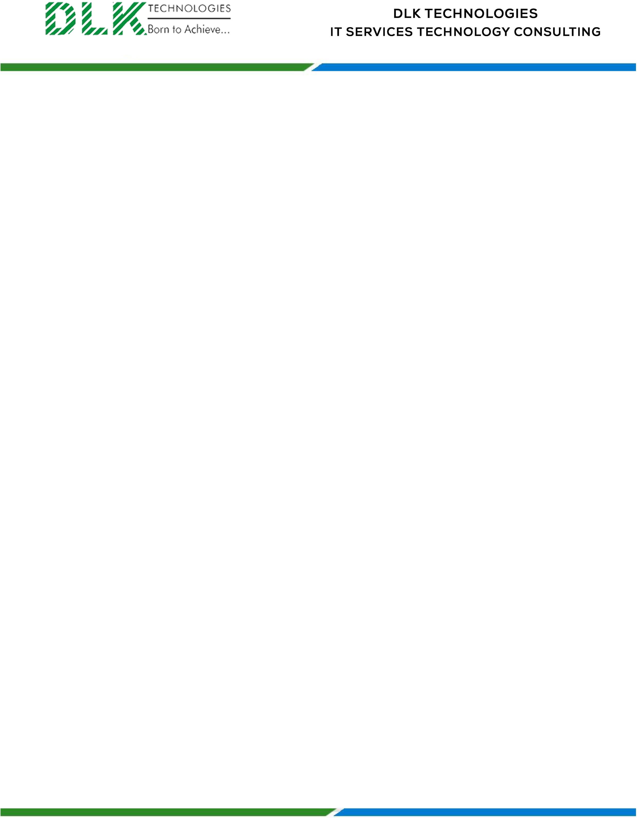

Date: 31 / January / 2023

**To**

Department of MBA,

Head of Department,

AVC college of engineering, Mayiladudhurai-609305

**Sub: Letter of Internship Acceptance**

This is to certify that **MS ANUJA A (REG NO: 820321631003)** second year student has accepted the Internship Work duration from **01th February 2023 to 30th April 2023** under the domain of **“Human Resource”.** During the Internship, all information and data collected from you should be kept confidential.

We appreciate your interest in **DLK TECHNOLOGIES**

For **DLK Technologies Pvt Ltd,**

**HR Manager**

**VELMURUGAN J**

**ADMIN OFFICE: DOOR NO: 66, GROUND FLOOR, NO. 172, RAAHAT PLAZA, ARCOT ROAD, VADAPALANI, CHENNAI - 26. TAMIL NADU, INDIA.**